Instinctive Bowhunter
“Recognition Overdue”
I was asked, or should say begged to shoot in a safari tournament known as “the World Bowhunter Team Championship, held in Fresno, California.
I’m a man of moderate income, so I was reluctant to part with the amount of money it would take for a plane trip, motel and food but I was assured by Roy McFarland, the NFAA director for Kentucky, that we would win the team event which paid one thousand dollars plus contingency awards. But, as we all know in archery, a lot of things can happen beyond our control and could cause us to lose. He also gave me assurance that we would be given lodging in a motor home by long time friends from California, Ben Rodgers and Ed Welch, who we were acquainted with while attending other NFAA national tournaments.
Well, it sounded too good to be true but I had never been to California, so I made the decision to enjoy the trip and the tournament, even if all our luck turned out bad.
This article would be extremely long if I described to you how much I enjoyed the scenery, weather and the friends I met, plus the hospitality I received while there, so on to the point of my story.
It was a beautiful morning and the targets were assigned with the teams together. In scoring, whichever team member scores the highest that score counts toward the team event and for individual scoring a separate card is kept.
From where we started on the range, I believe we had shot about five targets. Roy and I were five points down behind the first place team. Between targets, Roy was so shook up he would pace back and forth like a caged lion while waiting his turn to shoot. We had agreed that I would go first, and then he could buckle down if my score wasn’t up to par.
On our next target, an elephant at ninety-three yards down hill, the body area counted eight points for each arrow. The kill area, eighteen inches in diameter, counted ten points for each arrow and the red dot in the center which is six inches in diameter counted eleven points for each arrow. We shot two arrows at each targets.
Roy decided to shoot first and I agreed to spot for him with the binoculars. I couldn’t believe his first shot, seven o’clock in the red dot! I relayed this to Roy and with excitement in his voice he said” I believe I know where to hold for the dot.”
As he prepared for his second shot, I was thinking, if he could just get a kill, we would a twenty-one for our team score and we could pick up a few points to get us in a competitive position with our competition. We were shooting against the best instinctive bowhunters in the nation, Tom Daley, David Rudder, Ben Rodgers, Bob Nation, Jim Brown, Ed Welch, Louie Rangel Dave Lewis and Cal Vogt, just to mention a few. TWANG! Roy’s second arrow was on its way. THUMP! “Center of the red dot!” I shouted. He looked at me in disbelief and with a silly grin, grabbed his binoculars and looked at the target and yelled “ALL RIGHT!”
That shot gave us a score of twenty-two points and we were now five points on top in the team event. From the elephant shot until the forty-fifth target we didn’t look back, finishing thirteen points over the next highest team and tying the highest score ever shot.
We checked with those running the Safari World Bowhunter Championship and they said as far as they knew, not one bowhunter had ever scored twenty-two points on that target in the thirty years this shoot had been held and in 1986 there were close to seven hundred shooters.
We received the privilege of engraving our names on the perpetual elephant trophies under the 1985 winners, Dave Lewis and Bob Nation.
We were the proud 1986 Safari World Bowhunter Champions. Our pictures were published in The Western Bowhunter magazine under the heading of “The Best in the Nation”. This was a tournament which Roy and I would never forget.
Think about it. Shooting two arrows in a six inch dot at ninety-three yards. That’s 279 feet and instinctive shooting without sights. All I can say is “Fantastic, Roy!” And in my book you are now recognized among the best.
I sincerely hope this article will give Roy (Hoggie) McFarland, from Lexington, Kentucky, the recognition overdue.
Sincerely,
Tommy Doerr
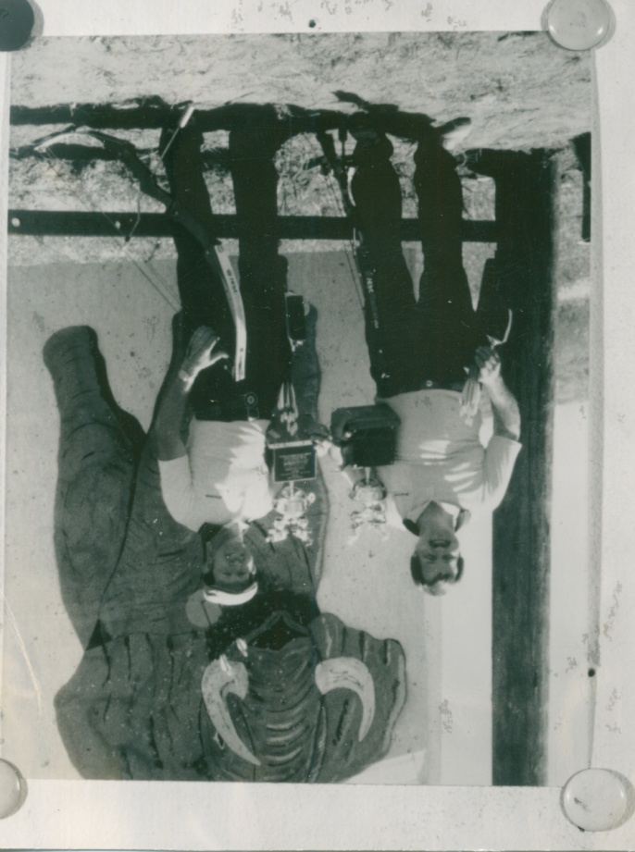
Louisville, Kentucky

*Tommy wrote this article some years back and gave it to me to publish in the KAA and the Chickasaw Archery club news letter. I found it while cleaning out some of my old papers and thought it was worthy of publishing. Roy McFarland has since passed away (March 5, 2007). Tommy Doerr is 86 years old now and starting to slow down a little. A lot of old archers can remember a lot of fun times with them.
Frank Mosser

